ASR 5120: Add Net weight to Packing List

The requirement as below following.

* Add BD Logo on header
* Add Net weight in content (beside of Gross Wt)
* Add Net Weight in packing details (bottom part, beside of Gross Wt)

**From:** Zhi Ai, Huang   
**Sent:** Thursday, 12 February, 2015 5:55 PM  
**To:** Chan, Pei-Fong  
**Cc:** Jack, Fong  
**Subject:** RE: WMS Packing List

HI PeiFong,

The BD SAP system not proper maintaining the net weight.

So, can we just based on logic as Net Wt = Gross Wt – Empty pallet wt (or cold chain packing materials as like ice gel pack)

Or to create a flexible column in order to tick and manual key in Net Wt only when customer/ shipment required.

Will call you for further discuss.

*Best Regards,*

***ZhiAi, HUANG (Mr)***

*Senior Executive*

*Contract Logistics/SCM, Operations*

*Schenker Singapore (Pte) Ltd*

*5 Tuas View Lane, Singapore 637291*

*DID: +65 6795 2572  Mobile: +65 8383 8397*

Hi PeiFong,

BD customer would like to require Net weight to shown in packinglist.

Kindly assist to develop a packinglist as like a/m sample shows.

The requirement as below following.

* Add BD Logo on header
* Add Net weight in content (beside of Gross Wt)
* Add Net Weight in packing details (bottom part, beside of Gross Wt)

Kindly to call me when you free to discuss further.

WMS CHANGES: Deployed 2015.03.19

1. Add column netwgt to BAX_PACK_DTL
2. Packing Screen change to allow manual input netweight per package

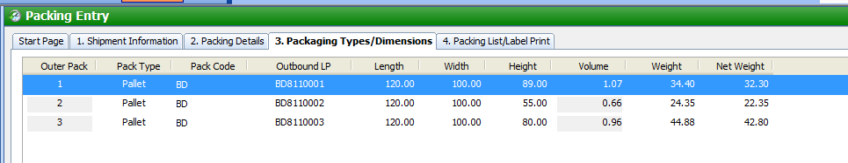

1. New packing list print with net weight
2. Forwarder field allow to input at the Packing Entry -> Shipment Information

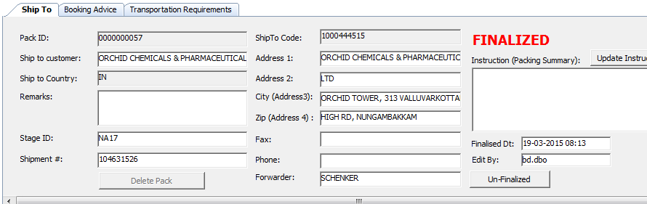

Packing list – netwgt

